**De Morgans Mansion**

**Main story**

The player find himself in an abandoned mansion. The player starts in the hallway of the mansion and appears to be locked in. Next to the exit there is a panel which appears to be missing a medallion. The first thing the player finds is a note:

“I once was lost but now I’m found, was blind but now I see. Five there are and together they form the key”

**Game Map**

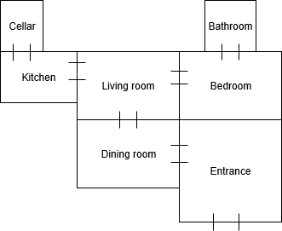

**Entrance**

You are standing in a large open hallway. In front of you there is an old stairway leading up to the second floor of the mansion. To the left there is a sturdy door behind a bookshelf. There is a large [chandelier] covered in spiderweb hanging from the ceiling.

**Go Left**: The [door] seems to be locked.

**Inspect Chandelier:** The chandelier looks unpolished and the candles seems to have burned out a long time ago. There is a [chain] hanging down from it which seems to be in reach.

**Pull Chain:** A [key] falls out.

**Get Key:** You receive a rusty bronze key.

**Go Left:** The [door] seems to be locked.

**Use Key On Door:** The door unlocks. Player enters the dining room.

**Interactable objects: Chandelier, door, key.**

**Dining Room**

You have entered the dining room. Immediately to the right there is a door.

**Go Right:** The door opens. The player enters the living room.

In the center of the room is a large dining table with some plates and empty glasses. There are signs of a large feast that ended abruptly. There must have been a large family living here…

Next to the end of the dining table is a burnt out [fireplace].

**Look [fireplace]:** Above the fireplace there is a dusty stone panel and some unused [matches]. While looking closer inside the fireplace you find that there is a pile of ashes with a bronze [piece] in it.

**Get [piece]:** You pick up the bronze piece.

**Interactable objects: Door, fireplace, piece (1th piece).**

**Living Room**

You have entered the living room. The floor of the room is covered in glass and the windows of the rooms seems to have been smashed in. This must have happened a long time ago since [ivy] have started to grow inside the room.

**Look [ivy]**: You stick your head out the window to examine where the ivy is coming from. Entangled in the dark green ivy there is an old wooden [torch].

**Get [torch]:** You pick up the torch. Maybe this can be used somewhere?

**Bedroom**

You enter the master bedroom. Under the large bed there is a hidden [safe].

Look [Safe]: The safe seems to be locked with a four-digit number.

Open [Safe]: Enter the code: 1 2 3 4

Inside the safe you find a golden [piece] with carved markings.

Get [piece]: You pick up the golden piece.

**Bathroom**

**Kitchen**

**Cellar**

Description 1: The cellar is completely dark. There is a distinct smell of mold, charcoal and burnt wood. While fumbling in the dark you feel something that resemble a [brazier].

Use Torch On Brazier: The room lights up with in an instant spark.

Description 2: The cellar is filled with wooden kegs and next to a